**Data, Database and File System**

**1.Data –**

**-Data is collection of raw facts or a figure which is unprocessed. It contains meaningless information.**

**Example -Orange**

**Description-now the data is orange but we don’t know what is means by orange whether it is color or fruit so this type of info is known as data.**

**2.Information –**

**-processed data or meaningful data is known as information.**

**Example-Orange color**

**-this is meaningful info means we can understand that the orange is color.**

**3.Database –**

**-Collection of interrelated data is known as database.**

**-It stores the data in the form of tables.**

**-It can be any size.**

**Example**

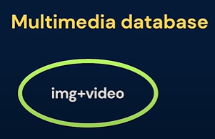 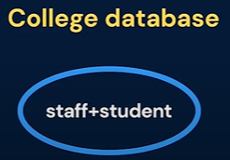

**In both databases the data is related with each other like in multimedia database images and videos having some connection with each other (ex, when you’re going on trip then you capture some photos and videos).**

**-Another one is college database. In these students having some relation with staff because if there no students then staff can’t teach and at another side if there is no staff so students can’t learn.**

**4.File System-**

**-An operating system’s approach for storing the data on storage units like hard drives is known as file system.**

**-In file system the data is stored into the files.**

**-Disadvantages of file system**

**1.Data Redundancy-**Same data present in multiple registers

**2.Poor Memory Utilization-**Filling memory due to maintaining multiple registers

**3.Data Inconsistency-**Variation in data across different registers

**4.Data Security-**Lack of security and integrity in file system

**5.Database Management System-**

**-DBMS is made of two words: database and management system. Database is collection of interrelated data, while management system contains some set of regulations or rule to manage the data.**

**-So, DBMS is combined software which allows us to perform some crud operations on data like insert, update delete and fetching the data.**

**-Applications**

**1.Bank database**

**2.College database**